Exercise 7: Financial Forecasting

Objective
Develop a financial forecasting tool that predicts future values using a recursive algorithm based on a fixed annual growth rate.

Algorithm
- Input the current amount, growth rate, and number of years.
- If years = 0, return the current amount.
- Otherwise:
  - Increase the amount by the growth rate.
  - Recursively calculate the value for the remaining years.
- Display the forecasted amount.
Forecast.java
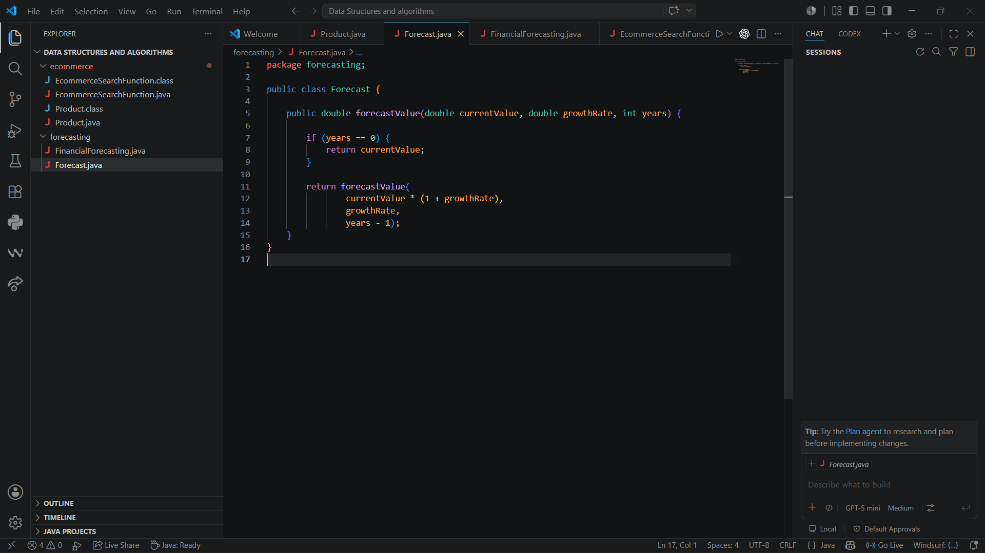

FinancialForecasting.java
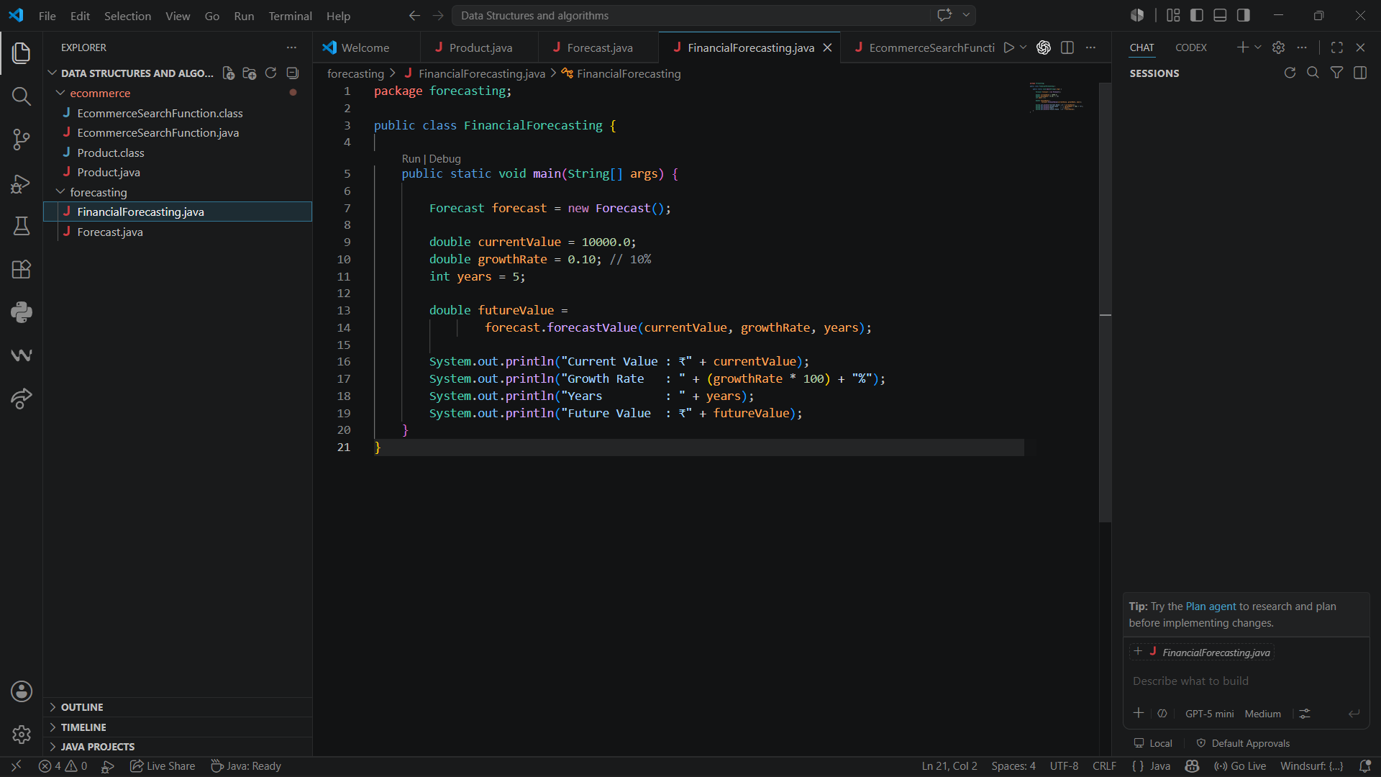

Output:
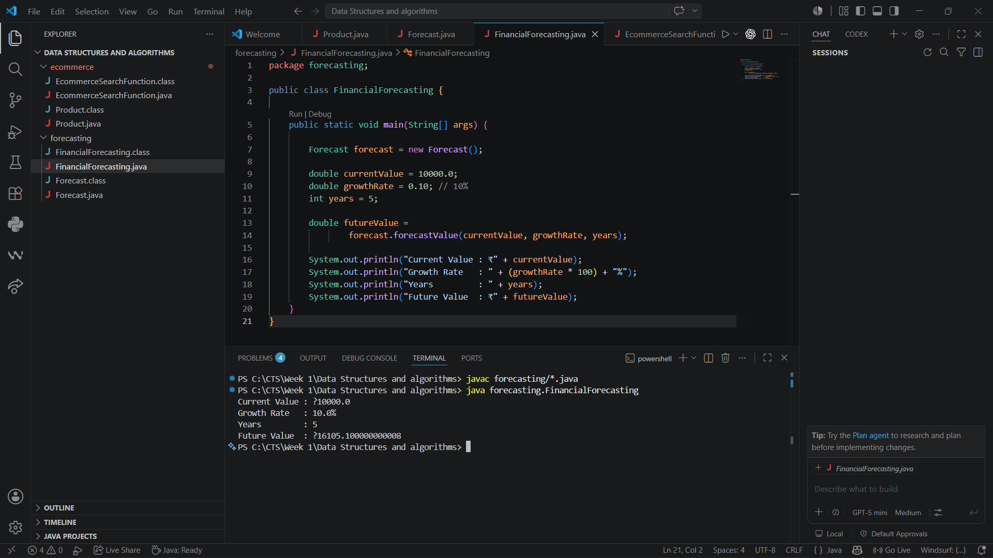

Time Complexity Analysis
Method | Complexity
Recursive Forecasting | O(n)
Space Complexity | O(n)
where n = number of years.
Optimization techniques:
● Memorization : stores previously computed results to avoid redundant calculations. Useful when the same parameters are used repeatedly.
● Iterative approach: it reduces space complexity to O(1). Avoids potential stack overflow for large periods.
● Mathematical formula : it reduces both time and space complexity to O(1). Most efficient but less flexible

Conclusion
The recursive approach calculates future financial values by repeatedly applying the growth rate for each year. It demonstrates the use of recursion in solving forecasting problems and is suitable for small to moderate forecasting periods.

